Lab - Implement Inter-VLAN Routing

Topology

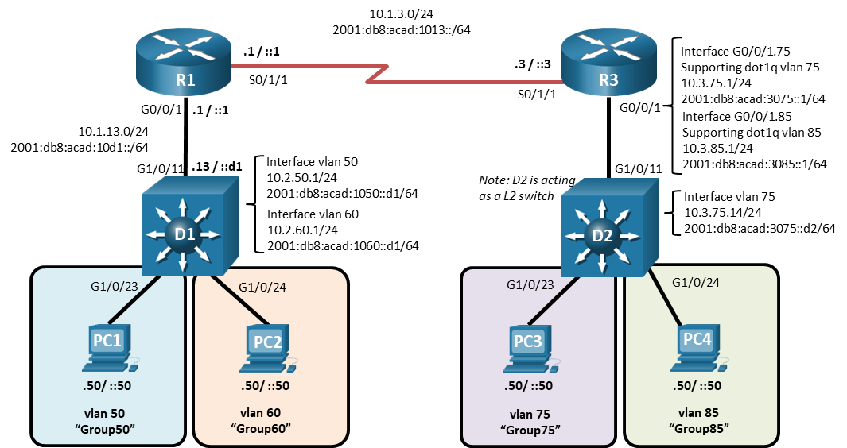

# Addressing Table

| Device | Interface | IPv4 Address | IPv6 Address | IPv6 Link-Local |
| --- | --- | --- | --- | --- |
| R1 | G0/0/1 | 10.1.13.1/24 | 2001:db8:acad:10d1::1/64 | fe80::1:1 |
| R1 | S0/1/1 | 10.1.3.1/24 | 2001:db8:acad:1013::1/64 | fe80::1:2 |
| D1 | G1/0/11 | 10.1.13.13/24 | 2001:db8:acad:10d1::d1/64 | fe80::d1:1 |
| D1 | VLAN50 | 10.2.50.1/24 | 2001:db8:acad:1050::d1/64 | fe80::d1:2 |
| D1 | VLAN60 | 10.2.60.1/24 | 2001:db8:acad:1060::d1/64 | fe80::d1:3 |
| R3 | S0/1/1 | 10.1.3.3/24 | 2001:db8:acad:1013::3/64 | fe80::3:1 |
| R3 | G0/0/1.75 | 10.3.75.1/24 | 2001:db8:acad:3075::1/64 | fe80::3:2 |
| R3 | G0/0/1.85 | 10.3.85.1/24 | 2001:db8:acad:3085::1/64 | fe80::3:3 |
| D2 | VLAN75 | 10.3.75.14/24 | 2001:db8:acad:3075::d2/64 | fe80::d2:1 |
| PC1 | NIC | 10.2.50.50/24 | 2001:db8:acad:1050::50/64 | EUI-64 |
| PC2 | NIC | 10.2.60.50/24 | 2001:db8:acad:1060::50/64 | EUI-64 |
| PC3 | NIC | 10.3.75.50/24 | 2001:db8:acad:3075::50/64 | EUI-64 |
| PC4 | NIC | 10.3.85.50/24 | 2001:db8:acad:3085::50/64 | EUI-64 |

# Objectives

Part 1: Build the Network and Configure Basic Device Settings

Part 2: Configure and Verify Inter-VLAN Routing on a Layer 3 Switch

Part 3: Configure and Verify Router-based Inter-VLAN Routing

Part 4: Examine CAM and CEF Details

# Background / Scenario

The methods used to move packets and frames from one interface to the next has changed over the years. In this lab you will configure Inter-VLAN Routing in its various forms and then examine the different tables used in making forwarding decisions.

**Note**: This lab is an exercise in configuring and verifying various methods of Inter-VLAN routing and does not reflect networking best practices.

**Note**: The routers and switches used with CCNP hands-on labs are Cisco 4221 and Cisco 3650, both with Cisco IOS XE Release 16.9.4 (universalk9 image). Other routers and Cisco IOS versions can be used. Depending on the model and Cisco IOS version, the commands available and the output produced might vary from what is shown in the labs.

**Note**: Ensure that the routers and switches have been erased and have no startup configurations. If you are unsure contact your instructor.

**Instructor Note**: Refer to the Instructor Lab Manual for the procedures to initialize and reload devices.

# Required Resources

* 2 Routers (Cisco 4221 with Cisco IOS XE Release 16.9.4 universal image or comparable)
* 2 Switches (Cisco 3650 with Cisco IOS XE Release 16.9.4 universal image or comparable)
* 4 PCs (PC with terminal emulation program, such as Tera Term)
* Console cables to configure the Cisco IOS devices via the console ports
* Ethernet and serial cables as shown in the topology

# Instructions

## Build the Network and Configure Basic Device Settings

In Part 1, you will set up the network topology and configure basic settings.

### Cable the network as shown in the topology.

Attach the devices as shown in the topology diagram, and cable as necessary.

### Configure basic settings for each device.

* + - 1. Console into each router, enter global configuration mode, and apply the basic settings using the following startup configurations.

Open configuration window

Router R1

no ip domain lookup

hostname R1

line con 0

exec-timeout 0 0

logging synchronous

exit

banner motd # This is R1, Inter-VLAN Routing Lab #

Router R3

no ip domain lookup

hostname R3

line con 0

exec-timeout 0 0

logging synchronous

exit

banner motd # This is R3, Inter-VLAN Routing Lab #

Switch D1

no ip domain lookup

hostname D1

line con 0

exec-timeout 0 0

logging synchronous

exit

banner motd # This is D1, Inter-VLAN Routing Lab #

interface range g1/0/1-24, g0/0, g1/1/1-4

shutdown

Switch D2

no ip domain lookup

hostname D2

line con 0

exec-timeout 0 0

logging synchronous

exit

banner motd # This is D2, Inter-VLAN Routing Lab #

interface range g1/0/1-24, g0/0, g1/1/1-4

shutdown

* + - 1. Set the clock on each device to UTC time.
      2. Save the running configuration to startup-config.

Close configuration window

## Configure and Verify Inter-VLAN Routing on a Layer 3 Switch

In Part 2, you will configure and verify inter-VLAN Routing on a Layer 3 switch. For this part, you will focus on the configuration of switch D1 and router R1.

**Note:** The default Switch Database Manager (SDM) template on a Catalyst 3650 running IOS XE supports dual-stacked operations and requires no additional configuration for our purposes.

If you are using an alternate device running Cisco IOS, check the SDM template with the privileged EXEC command **show sdm prefer** and verify that the ‘number of IPv6 unicast routes’ supported is not zero.

If it is zero, you must change the SDM template to one that supports IPv6 using the **sdm prefer** *template_name* global configuration command. The template name will vary depending on the IOS version. Changing the template will require a reboot.

### On D1, configure Inter-VLAN Routing.

Open configuration window

* + - 1. Configure D1 to support IP routing and IPv6 unicast routing.

D1(config)# **ip routing**

D1(config)# **ipv6 unicast-routing**

* + - 1. Create the VLANs and name them as specified in the topology.

D1(config)# **vlan 50**

D1(config-vlan)# **name Group50**

D1(config-vlan)# **exit**

D1(config)# **vlan 60**

D1(config-vlan)# **name Group60**

D1(config-vlan)# **exit**

* + - 1. Assign the G1/0/23 to VLAN 50 and G1/0/24 to VLAN 60.

D1(config)# **interface g1/0/23**

D1(config-if)# **switchport mode access**

D1(config-if)# **switchport access vlan 50**

D1(config-if)# **no shutdown**

D1(config-if)# **exit**

D1(config)# **interface g1/0/24**

D1(config-if)# **switchport mode access**

D1(config-if)# **switchport access vlan 60**

D1(config-if)# **no shutdown**

D1(config-if)# **exit**

* + - 1. Create the Switched Virtual Interfaces (SVI) that will support VLAN 50 and VLAN 60.

D1(config)# **interface vlan 50**

D1(config-if)# **ip address 10.2.50.1 255.255.255.0**

D1(config-if)# **ipv6 address fe80::d1:2 link-local**

D1(config-if)# **ipv6 address 2001:db8:acad:1050::d1/64**

D1(config-if)# **no shutdown**

D1(config-if)# **exit**

D1(config)# **interface vlan 60**

D1(config-if)# **ip address 10.2.60.1 255.255.255.0**

D1(config-if)# **ipv6 address fe80::d1:3 link-local**

D1(config-if)# **ipv6 address 2001:db8:acad:1060::d1/64**

D1(config-if)# **no shutdown**

D1(config-if)# **exit**

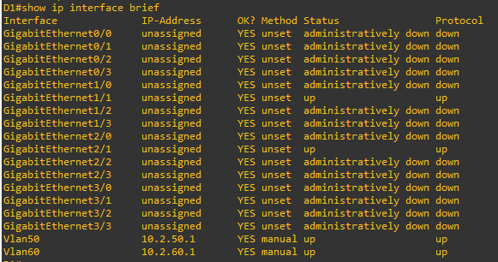

* + - 1. Configure PC1 with the addresses specified in the Addressing Table. Further assign default gateways of 10.2.50.1 and 2001:db8:acad:1050::d1.

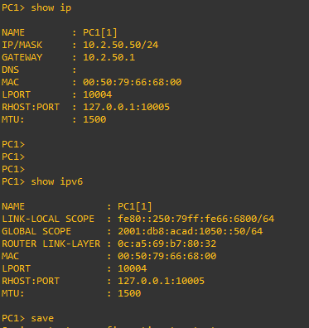

* + - 1. Configure PC2 with the addresses specified in the Addressing Table. Further assign default gateways of 10.2.60.1 and 2001:db8:acad:1060::d1.

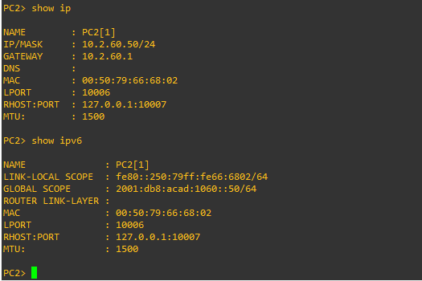

* + - 1. From PC1, ping PC2’s IPv4 and IPv6 address. Success indicates that D1 is performing Inter-VLAN Routing.

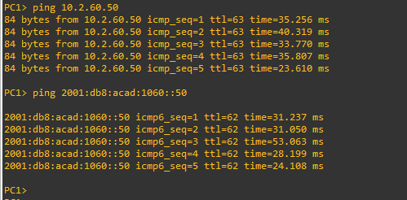

* + - 1. Examine the MAC address table on D1 with the command **show mac address-table dynamic**. You should see PC1 and PC2’s mac addresses listed with the ports they are connected to.

D1# **show mac address-table dynamic**

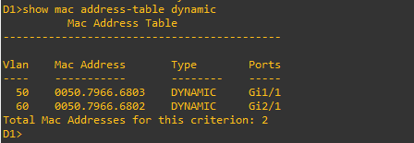

### On D1, configure a routed port and default routes towards R1

* + - 1. Configure interface G1/0/11 as a routed port with addressing as specified in the topology diagram.

D1(config)# **interface g1/0/11**

D1(config-if)# **no switchport**

D1(config-if)# **ip address 10.1.13.13 255.255.255.0**

D1(config-if)# **ipv6 address fe80::d1:1 link-local**

D1(config-if)# **ipv6 address 2001:db8:acad:10d1::d1/64**

D1(config-if)# **no shutdown**

D1(config-if)# **exit**

* + - 1. Verify that interface G1/0/11 is no longer associated with the VLAN database by issuing the command **show vlan brief | i g1/0/11**. There should be no output.

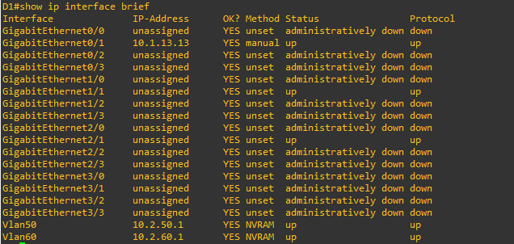

* + - 1. Configure static default routes for IPv4 and IPv6 that point towards the interface address at R1.

D1(config)# **ip route 0.0.0.0 0.0.0.0 10.1.13.1**

D1(config)# **ipv6 route ::/0 2001:db8:acad:10d1::1**

You may see the error message **%ADJ-3-RESOLVE_REQ: Adj resolve request: Failed to resolve 10.1.13.1**. This indicates that the switch sent an ARP for the MAC address of 10.1.13.1 and got no reply. We will configure that next.

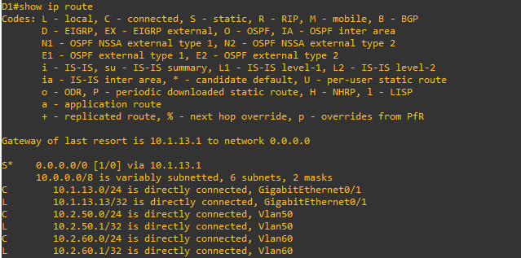

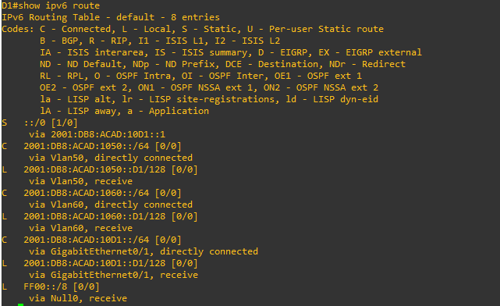

Close configuration window

### On R1, configure interface addressing and static routing.

Open configuration window

* + - 1. Configure R1 to support IPv6 unicast routing.

R1(config)# **ipv6 unicast-routing**

* + - 1. Configure the interfaces on R1 with the addresses specified in the Addressing Table.

R1(config)# **interface g0/0/1**

R1(config-if)# **ip address 10.1.13.1 255.255.255.0**

R1(config-if)# **ipv6 address fe80::1:1 link-local**

R1(config-if)# **ipv6 address 2001:db8:acad:10d1::1/64**

R1(config-if)# **no shutdown**

R1(config-if)# **exit**

R1(config)# **interface s0/1/1**

R1(config-if)# **ip address 10.1.3.1 255.255.255.0**

R1(config-if)# **ipv6 address fe80::1:2 link-local**

R1(config-if)# **ipv6 address 2001:db8:acad:1013::1/64**

R1(config-if)# **no shutdown**

R1(config-if)# **exit**

* + - 1. Configure routing on R1. Configure static routes to the networks supported by D1 and a default route for everything else point at R3.

R1(config)# **ip route 10.2.0.0 255.255.0.0 10.1.13.13**

R1(config)# **ipv6 route 2001:db8:acad:1050::/64 2001:db8:acad:10d1::d1**

R1(config)# **ipv6 route 2001:db8:acad:1060::/64 2001:db8:acad:10d1::d1**

R1(config)#

R1(config)# **ip route 0.0.0.0 0.0.0.0 10.1.3.3**

R1(config)# **ipv6 route ::/0 2001:db8:acad:1013::3**

R1(config)#

* + - 1. From R1, ping PC2 with IPv4 and IPv6. All pings should be successful.

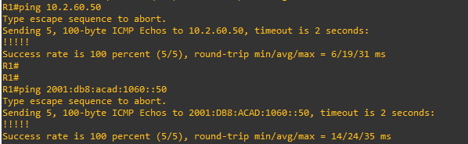

Close configuration window

## Configure and Verify Router-based Inter-VLAN Routing

**Note**: The default Switch Database Manager (SDM) template on a Catalyst 3650 running IOS XE supports dual-stacked operations and requires no additional configuration for our purposes.

If you are using an alternate device running Cisco IOS, check the SDM template with the privileged exec command **show sdm prefer** and verify that the ‘number of IPv6 unicast routes’ supported is not zero.

If it is zero, you must change the SDM template to one that supports IPv6 using **the sdm prefer *template_name*** global configuration command. The template name will vary depending on the IOS version. Changing the template will require a reboot.

### Configure D2 to support the required VLANs.

* + - 1. Create the VLANs and name them as specified in the topology. In addition, create vlan 999 and name it NativeVLAN.

Open configuration window

D2(config)# **vlan 75**

D2(config-vlan)# **name Group75**

D2(config-vlan)# **exit**

D2(config)# **vlan 85**

D2(config-vlan)# **name Group85**

D2(config-vlan)# **exit**

D2(config)# **vlan 999**

D2(config-vlan)# **name NativeVLAN**

D2(config-vlan)# **exit**

* + - 1. Assign the G1/0/23 to VLAN 75 and G1/0/24 to VLAN 85.
      2. Create a Switched Virtual Interface that will operate within VLAN 75.

D2(config)# **interface vlan75**

D2(config-if)# **ip address 10.3.75.14 255.255.255.0**

D2(config-if)# **ipv6 address fe80::d2:1 link-local**

D2(config-if)# **ipv6 address 2001:db8:acad:3075::d2/64**

D2(config-if)# **no shutdown**

D2(config-if)# **exit**

* + - 1. Create an IEEE 802.1Q-based trunk to R3. As a part of the configuration of the trunk, set the native VLAN to VLAN 999 and filter the VLANs allowed on the trunk down to only those that are configured.

D2(config)# **interface g1/0/11**

D2(config-if)# **switchport mode trunk**

D2(config-if)# **switchport trunk native vlan 999**

D2(config-if)# **switchport trunk allowed vlan 75,85,999**

D2(config-if)# **no shutdown**

D2(config-if)# **exit**

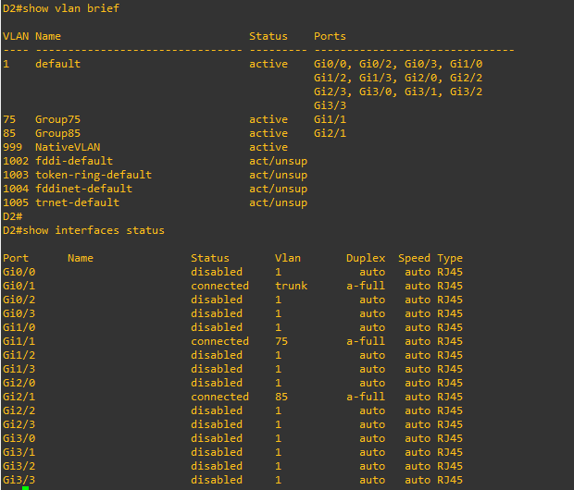

lose configuration window

### Configure R3 to support Inter-VLAN Routing.

* + - 1. Configure R3 to support IPv6 unicast routing.
      2. Configure the subinterfaces needed on R3 interface G0/0/1 to support the configured VLANs. Ensure an interface is created for the native VLAN 999.

Open configuration window

R3(config)# **interface g0/0/1**

R3(config-if)# **no shutdown**

R3(config-if)# **exit**

R3(config)# **interface g0/0/1.75**

R3(config-subif)# **encapsulation dot1q 75**

R3(config-subif)# **ip address 10.3.75.1 255.255.255.0**

R3(config-subif)# **ipv6 address fe80::3:2 link-local**

R3(config-subif)# **ipv6 address 2001:db8:acad:3075::1/64**

R3(config-subif)# **no shutdown**

R3(config-subif)# **exit**

R3(config)# **interface g0/0/1.85**

R3(config-subif)# **encapsulation dot1q 85**

R3(config-subif)# **ip address 10.3.85.1 255.255.255.0**

R3(config-subif)# **ipv6 address fe80::3:3 link-local**

R3(config-subif)# **ipv6 address 2001:db8:acad:3085::1/64**

R3(config-subif)# **no shutdown**

R3(config-subif)# **exit**

R3(config)# **interface g0/0/1.999**

R3(config-subif)# **encapsulation dot1q 999 native**

R3(config-subif)# **no shutdown**

R3(config-subif)# **exit**

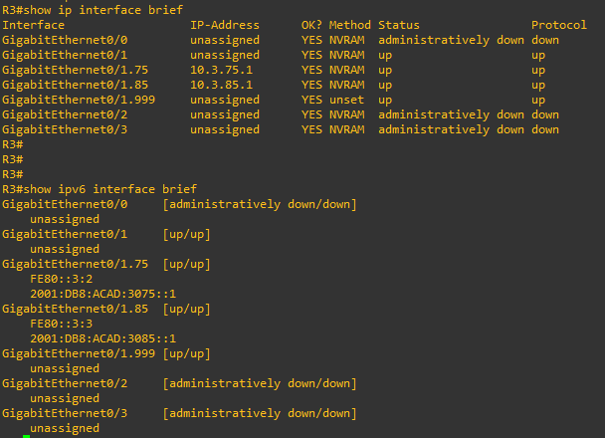

* + - 1. Configure PC3 with the addresses specified in the Addressing Table. Further assign default gateways of 10.3.75.1 and 2001:db8:acad:3075::1.

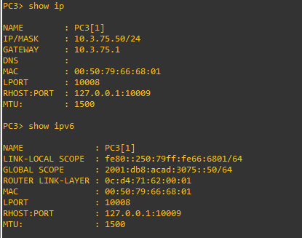

* + - 1. Configure PC4 with the addresses specified in the Addressing Table. Further assign default gateways of 10.3.85.1 and 2001:db8:acad:3085::1.

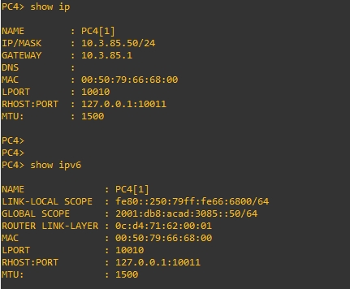

* + - 1. From PC3, ping PC4’s IPv4 and IPv6 address. Success indicates that R3 is performing Inter-VLAN Routing.

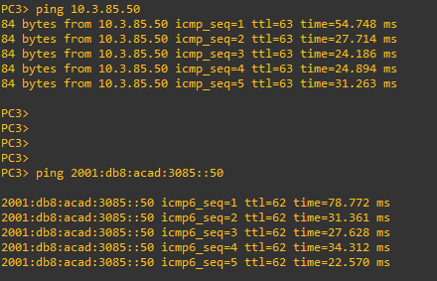

### Configure static routing to enable end-to-end reachability.

* + - 1. On R3, configure interface S0/1/1 with the addresses specified in the Addressing Table.

R3(config)# **interface s0/1/1**

R3(config-if)# **ip address 10.1.3.3 255.255.255.0**

R3(config-if)# **ipv6 address fe80::3:1 link-local**

R3(config-if)# **ipv6 address 2001:db8:acad:1013::3/64**

R3(config-if)# **no shutdown**

R3(config-if)# **exit**

* + - 1. On R3, configure a static default route for IPv4 and IPv6 that points to R1’s S0/1/1 interface addresses.

R3(config)# **ip route 0.0.0.0 0.0.0.0 10.1.3.1**

R3(config)# **ipv6 route ::/0 2001:db8:acad:1013::1**

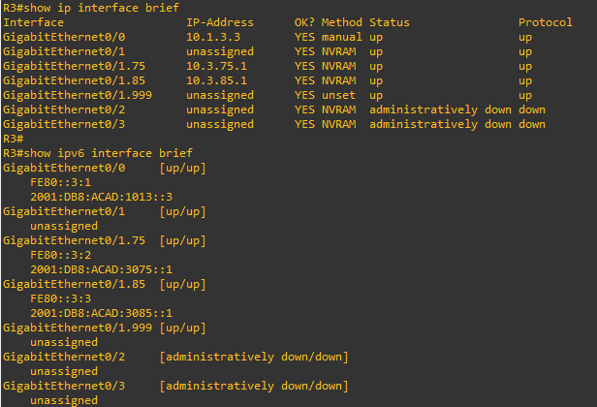

Close configuration window

* + - 1. On PC3, issue a ping to PC2. The ping should be successful. This indicates the routing solution is working in both directions.

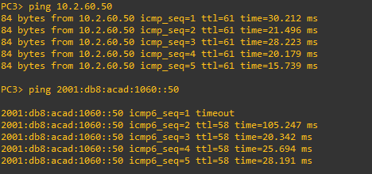

## Examine CAM and CEF Details

In Part 4, you will examine CEF details on the devices you have configured. The objective of Cisco Express Forwarding is to speed up the process of moving data from one interface to another. To do this, as much data as possible is precompiled into two tables, the Forwarding Information Base (FIB) and the Adjacency Table. These are basically shortcuts that identify what interface a packet should be sent out of and how it should be framed.

* + - 1. Issue the command **show ip cef** to see the compiled CEF table, which tells the device what to do with a frame or packet based on its destination address. This table gives the device a quick answer and keeps the CPU from getting directly involved. For example, packets destined to the 10.2.0.0/16 network are quickly resolved to the next-hop address of 10.1.13.13 exiting interface g0/0/1.

Open configuration window

R1# **show ip cef**

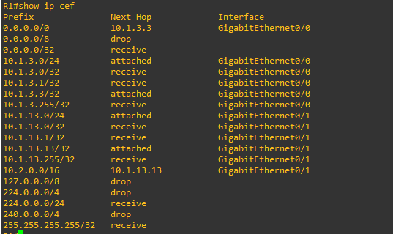

* + - 1. Issue the command **show adjacency**, which shows you the address neighbors on each interface.

R1# **show adjacency**

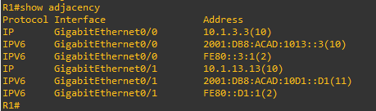

* + - 1. Expand this a bit and issue the command **show adjacency detail**, and you will see that the router has precompiled the Layer 2 headers and other details to allow it to package information quickly.

R1# **show adjacency detail**

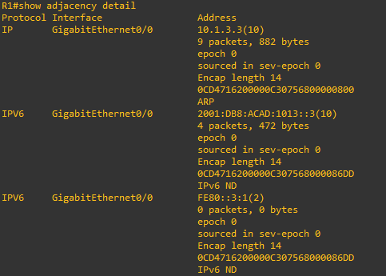

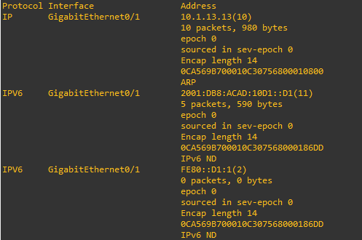

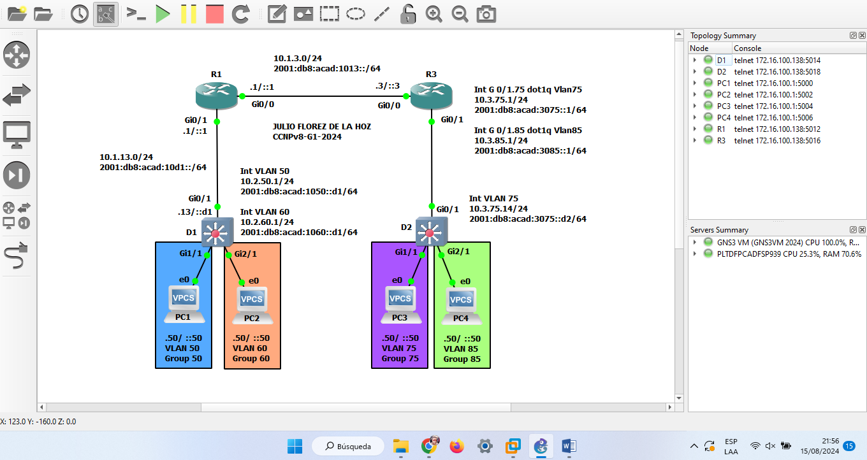

Close configuration window

# Router Interface Summary Table

| Router Model | Ethernet Interface #1 | Ethernet Interface #2 | Serial Interface #1 | Serial Interface #2 |
| --- | --- | --- | --- | --- |
| 1800 | Fast Ethernet 0/0 (F0/0) | Fast Ethernet 0/1 (F0/1) | Serial 0/0/0 (S0/0/0) | Serial 0/0/1 (S0/0/1) |
| 1900 | Gigabit Ethernet 0/0 (G0/0) | Gigabit Ethernet 0/1 (G0/1) | Serial 0/0/0 (S0/0/0) | Serial 0/0/1 (S0/0/1) |
| 2801 | Fast Ethernet 0/0 (F0/0) | Fast Ethernet 0/1 (F0/1) | Serial 0/1/0 (S0/1/0) | Serial 0/1/1 (S0/1/1) |
| 2811 | Fast Ethernet 0/0 (F0/0) | Fast Ethernet 0/1 (F0/1) | Serial 0/0/0 (S0/0/0) | Serial 0/0/1 (S0/0/1) |
| 2900 | Gigabit Ethernet 0/0 (G0/0) | Gigabit Ethernet 0/1 (G0/1) | Serial 0/0/0 (S0/0/0) | Serial 0/0/1 (S0/0/1) |
| 4221 | Gigabit Ethernet 0/0/0 (G0/0/0) | Gigabit Ethernet 0/0/1 (G0/0/1) | Serial 0/1/0 (S0/1/0) | Serial 0/1/1 (S0/1/1) |
| 4300 | Gigabit Ethernet 0/0/0 (G0/0/0) | Gigabit Ethernet 0/0/1 (G0/0/1) | Serial 0/1/0 (S0/1/0) | Serial 0/1/1 (S0/1/1) |

**Note**: To find out how the router is configured, look at the interfaces to identify the type of router and how many interfaces the router has. There is no way to effectively list all the combinations of configurations for each router class. This table includes identifiers for the possible combinations of Ethernet and Serial interfaces in the device. The table does not include any other type of interface, even though a specific router may contain one. An example of this might be an ISDN BRI interface. The string in parenthesis is the legal abbreviation that can be used in Cisco IOS commands to represent the interface.